

**EDUCATION**

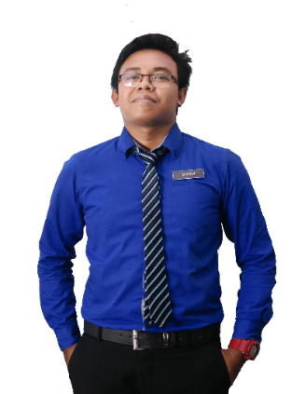

2017

Diploma in Tourism Management & Hospitality

CGPA: 3.37

**POLITEKNIK HULU TERENGGANU**



**EXPERIENCE**

July 2018 - July 2019

Guest Service Agent

**RED BY SIROCCO**

**HAZIQ** IRFAN

Feb 2015 - Dec 2015

**RESTAURANT THAI EXPRESS JAYA SHOPPING MALL**

MUHAMMAD HAZIQ IRFAN BIN HISHAMUDIN

Single / Male / Malay / 22 Years Old / 30 September 1997

Assistance Chef

Mar 2012 - Sept 2012

Promoter & Storekeeper

**AL-IKHSAN SPORTS SEKSYEN 14**



**OBJECTIVE**

Apr 2011 - Aug 2011

**KOKOPELLI TRAVELLERS BISTRO SEKSYEN 14**

Waiter



Seeking a position in any field that would allow me to use my strong passion for fresh graduate’s improvement together with skills and experience to contribute and make a significant different for any development

**EXTRACURRICULAR ACTIVITIES**

**POLITEKNIK HULU TERENGGANU**

2015 - 2017

* Squad Leader RELASIS Politeknik Hulu Terengganu
* President Club Of SAHABAT YADIM
* NYDP-1 MPP (Majlis Perwakilan Pelajar) 2015
* YDP MPP (Majlis Perwakilan Pelajar) 2017
* OUTREC 1
* Kayaking Star 1
* Kober Fun Fest Event Semester 3
* Volunteers for Visit Beautiful Terengganu 2017



**CONTACT**

**Address**

**Phone** **Email**

: No. 73 Jalan 14/29, 46100 Petaling Jaya, Selangor.

: +6013-2805916

: [resumecreative@yahoo.com](mailto:resumecreative@yahoo.com)



* Ikon Kepimpinan Pelajar Politeknik Hulu Terengganu 2017
* Ikon Politeknik Hulu Terengganu Hebat 2017
* Anugerah Ketua Program 2015-2017
* Majlis Perwakilan Pelajar Politeknik Hulu Terengganu 2016-2017

**ACHIEVEMENT / AWARDS**



**REFERENCES**



**MICROSOFT WORD**

**ADOBE PHOTOSHOP**

**MICROSOFT POWERPOINT**

**MICROSOFT EXCEL**

**COMPUTER SKILS**

**UJIN A.LOURDS**

Duty Manager,

RED By Sirocco

Phone: +6010-4699362

**AZIAN BINTI IBRAHIM**

Room Division Manager

RED By Sirocco

Phone: +6010-3993270



**PUAN SITI MURNI BINTI MAT ALI**

Academic Advisor

Tourism and Hospitality Department,

Politeknik Hulu Terengganu.

Phone: +6019-5260723

**LANGUAGES**

**ENGLISH**

**MALAY**